INVITATION
TO A POST-CONFERENCE WORKSHOP ON
STRENGTHS-BASED PRACTICE

FACILITATOR:
DR VENKAT PULLA
A LEADING EXPERT ON STRENGTHS-BASED PRACTICE

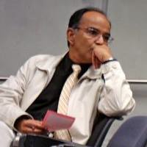

Dr Venkat Pulla is a Tata Institute of Social Sciences (TISS) alumnus and a Tata Dorabji Scholar, 1976-1977. He has been the foundation Head of the Social Work discipline in the Northern Territory University (1992-1995) (now known as Charles Darwin University) and currently he is the coordinator of the Social Work Discipline at the Australian Catholic University, Brisbane (McAuley Campus at Banyo). He has previously taught at the Charles Stuart University, New South Wales and at the University of the Sunshine Coast in Queensland.

Dr Venkat Pulla began his career teaching community development and organisational behaviour at the College of Social Work, Hyderabad and spent a few years in training public sector senior executives in urban development through British aid (DFID) funded projects for Metro cities in India through the Regional Centre for Urban and Environmental Studies, RCUES, Osmania University. In India he founded the Centre for Environment Concerns in Hyderabad as a reflective sequel to the Bhopal tragedy and initiated the first ever written Citizen’s Report on the City of Hyderabad and it’s Physical Environment.

In Australia he founded the Brisbane Institute of Strengths Based Practice and the Impetus Global, Brisbane, that offer solution-focused training in the broad realm of strengths-based strategies for human services and the corporate sector. He is a practitioner and a motivational speaker on the strengths approach in social work and self-reliance.

He has published widely, with his most recent writings in the areas of green social work, spirituality, coping, resilience and building hope. His research interests include poverty interventions, health rights and transition countries. A confluence of the Schools of Positive Psychology, Appreciative Inquiry, Strengths-based Practices and Mindfulness Practices describe the evocative approach of Dr Venkat Pulla.

Date: 8 October 2015
Time: 09H00- 12H00
Venue: Miriam Makeba Centre of Performing Arts,
University of Fort Hare (UFH), East London Campus
Hosted by: Department of Social Work and Social Development, UFH

To register your interest in attending,
please send your name and contact details to
Carmen at swsd2015@aceconferences.co.za

PLEASE NOTE THAT THE WORKSHOP WILL ONLY ACCOMMODATE 50 DELEGATES. PLEASE REGISTER SOON TO AVOID DISAPPOINTMENT

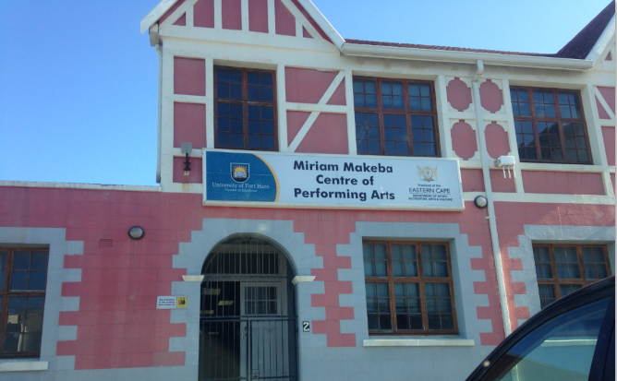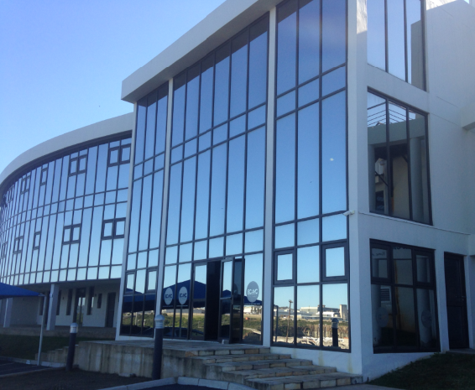
VIEWS OF THE WORKSHOP VENUE

